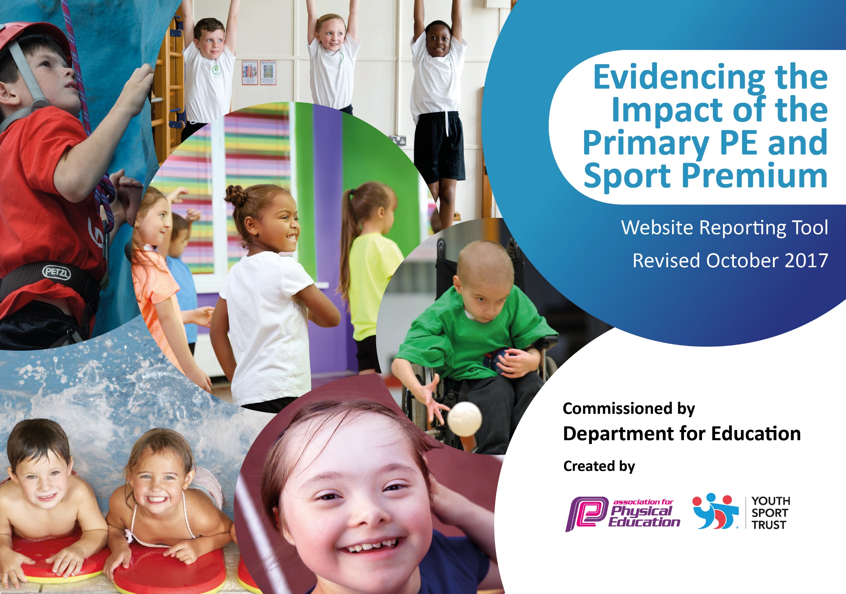

Buckminster Primary School

**2023/24 review**

Schools must use the funding to make **additional and sustainable** improvements to the quality of PE and sport they offer. This means that you should use the Primary PE and Sport Premium to:

* develop or add to the PE and sport activities that your school already offers
* 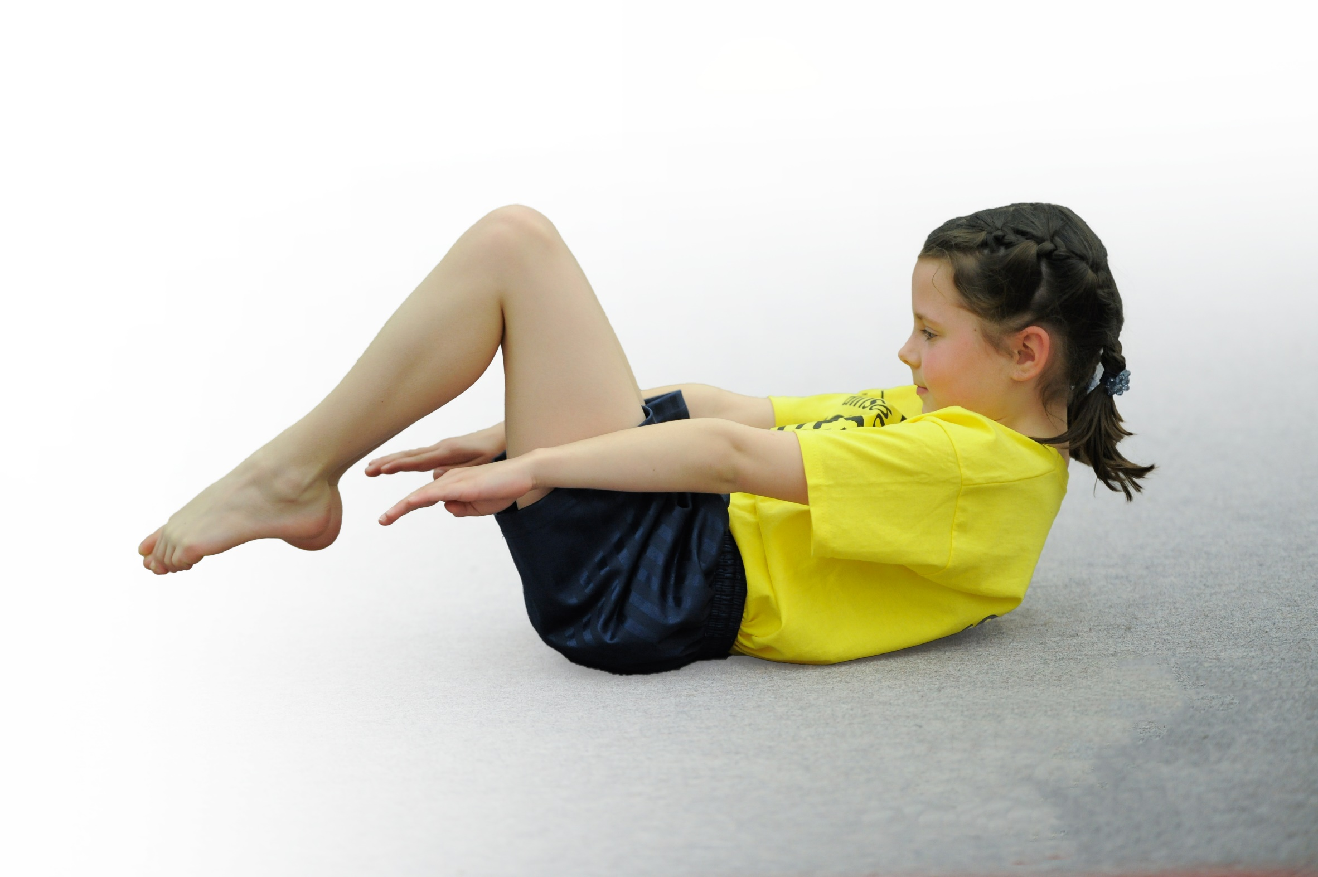build capacity and capability within the school to ensure that improvements made now will benefit pupils joining the school in future years

Please visit [gov.uk](https://www.gov.uk/guidance/pe-and-sport-premium-for-primary-schools) for the revised DfE guidance including the 5 key indicators across which schools should demonstrate an improvement. This document will help you to review your provision and to report your spend. DfE encourages schools to use this template as an effective way of meeting the reporting requirements of the Primary PE and Sport Premium.

We recommend you start by reflecting on the impact of current provision and reviewing the previous spend.

Under the [Ofsted Schools Inspection Framework](https://www.gov.uk/government/publications/school-inspection-handbook-from-september-2015), inspectors will assess how effectively leaders use

the Primary PE and Sport Premium and measure its impact on outcomes for pupils, and how effectively [governors](https://www.gov.uk/government/publications/governance-handbook) hold them to account

for this.

Schools are required to [publish details](https://www.gov.uk/guidance/what-maintained-schools-must-publish-online#pe-and-sport-premium-for-primary-schools) of how they spend this funding as well as on the impact it has on pupils’ PE

and sport participation and attainment.

We recommend regularly updating the table and

publishing it on your website as evidence

of your ongoing review into how you are using the money

to secure maximum, sustainable impact. To see an example of how to complete the table please click [HERE](http://www.afpe.org.uk/physical-education/wp-content/uploads/Template-Exemplification.pdf).

Support for review and reflection - considering the 5 key indicators from DfE, what development needs are a priority for your setting and your students now and why? Use the space below to reflect on previous spend, identify current need and priorities for the future.

|  |  |
| --- | --- |
| Key achievements to date: 2023/24 | Areas for further improvement and baseline evidence of need: |
| 1. Our sports apprentice completed their level 4 apprenticeship. Our sports coach and apprentice have continued to support the school in delivering more sporting and physical opportunities across school 2. Signed up to participate in more competitive fixtures and tournaments through Inspire + 3. Sports clubs run every evening by a sports coach – free to all PP children 4. Get Set 4 PE Scheme has been embedded throughout the school – teachers are supported by the PE coordinator and sports coaches to deliver PE lessons. 5. Two visits to PGL – raft building, tag archery, orienteering and problem solving. 6. Competed in Sky dance theatre and Mini Olympics to encourage competition, perseverance, resilience, and teamwork | 1. Increase opportunities to take part in a wider range of sports (competitive and non-competitive) through the Melton and Belvoir Sports 2. Target pupils who are more sedentary and Pupil Premium pupils – encourage more to participate in extracurricular activities. 3. Sports coach to coordinate PE (alongside the Head Teacher) across the school. 4. Provision for active learning and play at playtimes to be developed. |

|  |  |
| --- | --- |
| Meeting national curriculum requirements for swimming and water safety (7 children) | Please complete all of the below: |
| What percentage of your Year 6 pupils could swim competently, confidently and proficiently over a distance of at least 25 meters when they left your primary school at the end of the academic year? | 100% |
| What percentage of your Year 6 pupils could use a range of strokes effectively [for example, front crawl, backstroke and breaststroke] when they left your primary school at the end of last academic year? | 100% |
| What percentage of your Year 6 pupils could perform safe self-rescue in different water-based situations when they left your primary school at the end of last academic year? | 100% |
| Schools can choose to use the Primary PE and Sport Premium to provide additional provision for swimming but this must be for activity **over and above** the national curriculum requirements. Have you used it in this way? | **No** |
|  | |

**Action Plan and Budget Tracking**

Capture your intended annual spend against the 5 key indicators. Clarify the success criteria and evidence of impact that you intend to measure to evaluate for students today and for the future.

|  |  |  |  |  |
| --- | --- | --- | --- | --- |
| **Academic Year:** 2024-2025  **Total fund allocated:** £16,790  (£4000 Inspire +) | | | | |
| **Key indicator 1: The engagement of all pupils in regular physical activity** | | | | |
| School focus with clarity on intended **impact on pupils**: | Actions to achieve: | Funding allocated: | Evidence and impact (Reviewed September 2025) | Sustainability and suggested next steps (Reviewed September 2025) |
| Ensure all children have the opportunity to take part in a broad and interesting range of sporting activities, both developmental and competitive.  Children will develop a positive attitude towards physical activity, promoting a healthier lifestyle, both physically and mentally.  Children will have opportunity to develop broader range of interests when partaking in sport.  All children will have opportunities to partake, regardless of learning and physical needs. | PE LTP and MTP mapped out for the year – each class has 2 X1hr PE lessons a week plus 1X 30min Dumba session. 50% of lesson are provided by a sports coach.  Wrap around care 5 days a week has a sports theme for the first hour – this is provided by a sports coach (20% of children regularly attend)  All children partake in PE lessons  Mixed PE lesson to support engagement weekly – Work out Wednesday. Yr 6 children are sports ambassadors. | £5300 sports coach  £458 – PE Scheme |  |  |

|  |  |  |  |  |  |  |  |
| --- | --- | --- | --- | --- | --- | --- | --- |
| **Key indicator 2: The profile of PE and sport being raised across the school as a tool for whole school improvement** | | | | | | | |
| School focus with clarity on intended **impact on pupils**: | Actions to achieve: | | Funding allocated: | | | Evidence and impact (Reviewed September 2025) | Sustainability and suggested next steps (Reviewed September 2025) |
| Raise the profile of sport and physical activity in school by planning and implementing a broad range of Sport and PE opportunities and ensure that staff have the equipment and resources needed to deliver high quality teaching.  Children will benefit from more opportunities to take part in physical activity, which will impact on both mental and physical health and wellbeing. | Continue to offer a wider range of activities both within and outside the curriculum that promote physical activity and are accessible to all – Work out Wednesday  In addition to the existing wide range of opportunities that we currently offer, introduce competitions in sport.  Aim to increase the number of children engaged  Focus particularly on those children who do not take up additional PE and Sports opportunities  Ensure new Sports Clubs timetable disseminated to pupils and parents and uploaded to website | | Sports coach (as above)  PE Scheme(as above)  £1324 sports resources and equipment  £2518– Mini buses  £600 – Drumba  £2000 – M&B membership | | |  |  |
| **Key indicator 3: Increased confidence, knowledge and skills of all staff in teaching PE and sport** | | | | | | | |
| School focus with clarity on intended  **impact on pupils**: | | Actions to achieve: | | Funding  allocated: | Evidence and impact (Reviewed September 2025) | | Sustainability and suggested next steps (Reviewed September 2025) |
| Ensure that teaching and learning in PE continues to be of high quality and staff feel confident in the knowledge, skills and resources they have access to - new staff in place 2023/24.  Children will develop good physical literacy, problem solving and evaluative skills. | | Continue to build on the high quality PE offer that has been established.  Subject Leadership CPD will be offered to the lead.  Targeted CPD will be offered to existing staff to ensure sustainability.  Support from subject leaders at John Ferneley to help support PE CPD.  Continue to develop new and existing staff to ensure sustainability.  Build on skills to improve children’s ability to “read” what’s going on in particular sporting situations and reacting appropriately – linking to our Behaviour Culture. | | Sports coach (as above)  PE Scheme(as above) |  | |  |
| **Key indicator 4: Broader experience of a range of sports and activities offered to all pupils** | | | | | | | |
| School focus with clarity on intended  **impact on pupils:** | | Actions to achieve: | | Funding  allocated: | Evidence and impact (Reviewed September 2025) | | Sustainability and suggested next steps (Reviewed September 2025) |
| Ensure children have access to appropriate, high quality PE equipment/kits Children benefit from learning using high quality equipment and taking part in realistic sport scenarios and a kit to identify the school as a team | | Cost of new resources: Children have benefited from good quality, fit for purpose equipment to use, both in PE lessons and in clubs. This will continue to have a positive impact on children’s experiences | | £500 – team kit / PE kits for families that need it.  Resources (as above) |  | |  |
| **Key indicator 5: Increased participation in competitive sport** | | | | | | | |
| School focus with clarity on intended  **impact on pupils**: | | Actions to achieve: | | Funding  allocated: | Evidence and impact (Reviewed September 2025) | | Sustainability and suggested next steps (Reviewed September 2025) |
| To introduce additional, inclusive competitive sports opportunities providing the opportunity for all children to participate | | Local school Competition through Melton and Belvoiur Games | | M&B membership (as above)  Hire of coach / Mini bus(as above)  Cost of sports coach (as above) |  | |  |