

Admissions Policy 2024

Review date | September 2024
Signed: J Orridge (Head Teacher) | 
Signed: (CoG) | 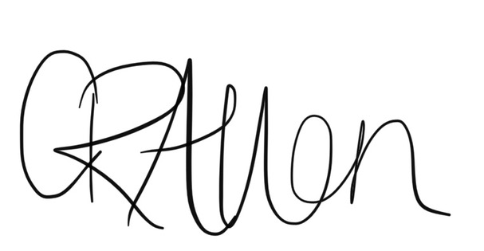
Next review date | September 2025

Julia Orridge
Head Teacher

The Governing Body of Buckminster School has adopted the following arrangements with respect to the admission of pupils to the school.

Pupils will be admitted in September in the year they become five years of age. The number of intended admissions for the year commencing 1st September 2024 will be 15 and the published admissions number for each year group is 15. Buckminster School follows the agreed co-ordinated scheme for admissions and this is available from the local authority. We will take account of our statutory responsibilities in respect of children with special educational needs.

Where applications for admission exceed the number of places available the following criteria will be applied, to decide which children to admit:

1 Children in public care.

2 Children who live within the civil parishes of Buckminster and Sewstern and the surrounding villages.

3 Where a child has a brother or sister currently attending the school at the time a place is needed.

4 Where there are medical grounds, supported by a doctor’s certificate for admitting the child.

5 Distance of the child’s home to the school, with those living nearer being accorded the higher priority, which will be decided by the shortest measured route on the public highway between the post office address point of the home and the post office address point of the school.

If any of the oversubscription criteria have too many applicants, then the tie break will be by driving distance by the shortest measured route on the public highway between the post office address point of the home and the post office address point of the school. The child living closer to the school will be offered the place.

Right of Appeal
If parents wish to appeal against a decision to refuse entry, they can do so by applying to the Clerk to the Governors at the school. An independent panel considers all such appeals and its decision is binding for all parties concerned.

Definition and Notes
1 A child in public care is a child who is in the care of a local authority or provided with accommodation by them in accordance with section 22 of the Children Act 1989.

2 Sibling:
- A full brother or full sister, whether or not resident in the same household.
- Another child normally resident for the majority of term time in the same household, for whom an adult in the household has parental responsibility as defined in the Children Act 1989 or Section 579 of the 1996 Education Act.
- In the case of twins (or two siblings in the same age cohort) and where there is only one place available in the school, both will be considered together as one application. The school will be authorised to exceed its admission number by one, except if this breaches infant class size regulations. In this case, parents will be given the choice, either to accept the one place available and a place in a different school for the other twin (or sibling) or to accept places in the nearest school with two places. In the latter instance, the County Council may provide free transport for both children, provided the distance from home to school qualifies.

3. 1 Distance from home to school
Driving distance: This is the shortest measured route on the public highway between the Post office address point of the home and the post office address point of the school.

3. 2 Home address
This is the address where the child lives for the majority of the school term time with a parent who has parental responsibility as defined in the Children Act 1989 and a parent includes a person who is not a parent but who has responsibility for them. This could include a pupil’s guardians but will not usually include other relatives such as grandparents, aunts, uncles etc unless they have all the rights, duties, powers and responsibilities and authority which by law a parent of a child has in relation to the child and their property.

Where a child lives normally during the school week with more than one parent at different addresses, the home address for the purposes of school admissions will be that of the parent who lives closest, by straight line distance.

Equally, where a family possesses more than one home, the Governors will take as the home address the address where the family and child normally live for the majority of the school term time.

Name: Julia Orridge

Date Agreed: September 2024

Supported by: Full governors.

Date to be reviewed: September 2025

Chair of Governors

