

‘We aspire to develop active and responsible global citizens’

Behaviour Policy
2022/23

Headteacher: Mrs D Clarke
Chair of Governors: J Roberts ……………………………………..
Signed copy in school office
Date: 31.03.23
Review annually

Philosophy
We believe in positive behaviour management based on the good relationships fostered within the school community. We have high expectations and utilise a wide range of strategies to encourage and reward all children in taking responsibility for their own actions.

We use our behaviour policy to help pupils improve their attitudes & behaviour in the classrooms, on the playgrounds and when representing the school on visits. When children meet behaviour expectations, they will have the opportunity to join in with the celebrations and rewards systems we have in school.

Aims of a positive approach to behaviour to help each of our children achieve their full potential:
- To encourage a calm, purposeful and happy atmosphere within the school.
- To foster positive, caring attitudes towards everyone, where achievements at all levels are acknowledged and valued.
- To encourage increasing independence and self-discipline, so that each child learns to accept responsibility for their own behaviour.
- To support pupils to develop further and learn from their mistakes.
- To have a consistent approach to behaviour throughout the school with parental co-operation and involvement giving a common purpose, in which there is mutual respect.
- To ensure that pupils behave in a responsible manner, showing consideration, courtesy, and respect for others at all times.
- To ensure safety through making the boundaries of acceptable behaviour clear.
- To recognise the value of each person as an individual with unique gifts and talents.
- Establishing and insisting on routines for:
- Entering the classroom.
- Seating arrangements.
- Sharing a visual timetable for the day.
- Distributing and using the equipment needed.
- Transition between carpet spaces and classroom tables.
- Walking between areas of the school buildings.
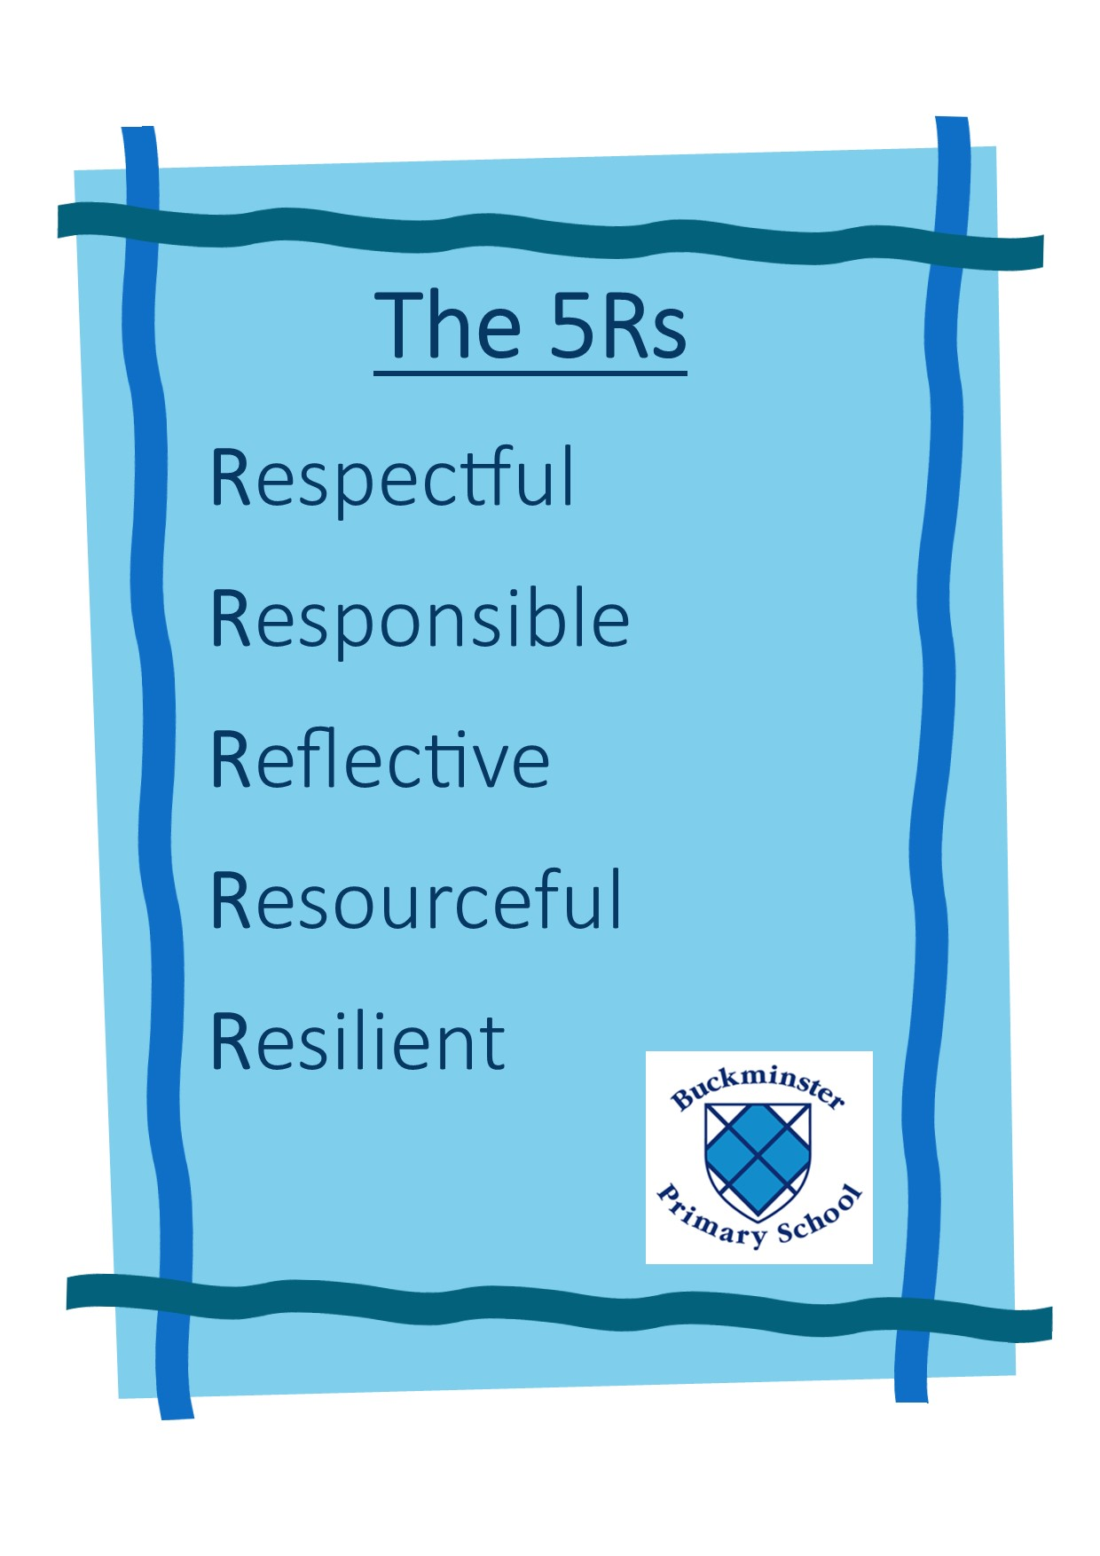
- To follow the 5Rs.

Key premises of our approach
- Being ‘fair’ is not about everyone getting the same (equality) but about everyone getting what they need (equity).
- Behaviour is a form of communication. We view behaviour as a communication of an emotional need (whether conscious or unconscious), and we will respond accordingly.
- Putting relationships first. This requires a school ethos that promotes strong relationships between staff, pupils, and their parents/carers. It also relies on creating a positive school culture and climate that fosters connection, inclusion, respect, and value for all members of the school community.

Positive Behaviour Management
A major aim of the school policy is to encourage children to practise good behaviour by operating a system of praise and reward. This is for all children. Positive language focuses on identifying things that are going well, good choices that have been made, as well as tackling poor choices. We accept that ultimately the children are responsible for their own actions. This is reflected in our use of the language of choice. This fosters a move away from the idea that children are inherently ‘bad’ or ‘good’, they are however making the right or the wrong choices.

All class teachers use a range of rewards to positively reinforce children’s behaviour and achievements. These include:
- Verbal praise
- Showing work
- Work taken to previous teacher / head teacher
- Stickers
- Merits = certificates given out at the end of each week
- Children receiving a merit certificate go on the weekly BITES newsletter
- Head teacher’s special awards
- House points

Before and After School
No ball games or running around on the playground before school starts or after school due to parents and small children.

Lunchtime/break times
The rules applying to break times should be covered regularly by the Class Teacher and will cover specific aspects concerning the use of play equipment and movement to and from classrooms.
When moving from the playground to the school field children are expected to line up with their class and walk in an orderly manner to the field. At the end of break and lunchtime the bell will ring, and children stand still in silence, on the second ring children are to walk and line up with their class without talking.

Sanctions

Stage | Sanction | Typical but not exhaustive behaviours warranting such a sanction
Stage 1 | Verbal warning, change of seating. | Low level unwanted single event behaviour e.g not listening, dropping litter, poor manners etc.
A second verbal warning can also be given if needed before stage 2.

Stage 2 | Time out within the classroom, or time out with lunchtime supervisor. | Continued low level unwanted behaviours. Refusal to follow reasonable instructions. | Incidents, actions and sanctions are recorded on CPOMS.
Stage 3 | Time out with AHT or another teacher. | Rudeness. Lack of respect shown. Use of inappropriate language. Lack of effort towards class tasks. Unwanted persistent low-level behaviour or a single more serious event. Refusal to follow reasonable instructions. | Incidents, actions and sanctions are recorded on CPOMS.
Stage 4 | Withdrawal from break time or lunchtime with peers. | Continued behaviours as above.  Single more serious event. | Incidents, actions and sanctions are recorded on CPOMS.
Stage 5 | Send to Head Teacher and / or possible withdrawal of privileges. | Continuing behaviours as above.  Fighting. Repeated events of unwanted behaviour.  Parents / Carers informed by class teacher.  Possible child-on-child abuse. | Incidents, actions and sanctions are recorded on CPOMS.
Stage 6 | Send to Head Teacher, parents contacted and / or possible withdrawal of privileges.  * This stage could lead to the stages below following the outcomes of meetings and reviews of evidence. | Bullying. Cyber-bullying in school. Serious single event. Persistent low-level behaviours. Damage to school property. Stealing.  Parents / Carers informed by class teacher.  Possible child-on-child abuse. | Incidents, actions and sanctions are recorded on CPOMS.
Internal Suspension |  | Serious single event.  Continuing persistent behaviours over a period of time.  Parents / Carers informed by head teacher. | Incidents, actions and sanctions are recorded on CPOMS.
Fixed Term Suspension  * Fixed term suspensions could lead to a permanent exclusion following reviews of evidence and advice taken. |  | Persistent disruptive behaviour. Serious single event usually where the physical or emotional safety of other children or staff is a concern. Evidence of bullying. Evidence of in school cyberbullying. Evidence of behaviours of a homophobic or racist nature.  Parents / Carers informed by head teacher. | Incidents, actions and sanctions are recorded on CPOMS.
Permanent Exclusion |  | In response to a serious breach or persistent breaches of the school’s behaviour policy and where allowing the pupil to remain in school would seriously harm the education or welfare of the pupil or others in the school.  Parents / Carers informed by head teacher. | Incidents, actions and sanctions are recorded on CPOMS.

Allegations of bullying are all investigated in line with the anti-bullying policy, and recorded on the CPOMS system.

If a child shows evidence of child-on-child abuse, violent, threatening, aggressive or verbal (including racial) behaviour they are sent (accompanied) immediately to the Head Teacher. Behaviour is recorded on CPOMS system. Parents are informed of this.

We believe that children deserve a “fresh start” every day and that consequences incurred during one day should not, where possible, be carried over to the next day. However, we acknowledge this might not always be viable. For example, if an incident occurs during an afternoon session, the sanction could take place the following day. From time-to-time, teachers will remind the whole class that every day is a new day and a chance to do even better than the day before.

Children who are constantly being given “warnings” may need a behaviour plan or pastoral support, to address a particular behavioural problem. Teachers are asked to seek advice and support from the Head Teacher or another member of SLT, should this happen. Wherever possible, staff at Buckminster Primary School will always endeavour to make the necessary reasonable adjustments. When managing children on the Special Education Needs Register, the staff will take extra care in monitoring and administering reasonable adjustments in order for the children to reach their full potential academically and socially.

Additional Needs and Inclusion
Our aim at Buckminster Primary School, is to be inclusive. We recognise that all children have individual needs, and in some cases, it may be appropriate to provide alternative behavioural structures, such as:
- Individual reward systems
- Regular monitoring by staff and the Headteacher and reports to parents / carers

Persistent poor behaviour should be reported to the SENDCO / Head teacher so that if required, additional behavioural support may be available from external agencies.

An analysis of the pupils’ needs will be carried out with input from parents / carers and the staff who work with the pupil. The school will implement a behaviour support plan. This will be made up of information gathered at the analysis stage and will include tailored provision and intervention to aid the removal of any barriers to learning.

We aim to make reasonable adjustments to assist the pupil with additional needs, therefore there will be a clear process that will be followed to prevent discrimination and promote equality and inclusion. Any additional support that has been agreed and implemented will be reviewed and evaluated. Parents will be expected to be involved in the setting and reviewing outcomes and provision.

CPOMS
CPOMS is a software application for monitoring child protection, safeguarding, pastoral and welfare issues. CPOMS is a system to help with the management and recording of child protection, behavioural issues, bullying, special educational needs and domestic issues. Using CPOMS, the school can ensure that pupils are safe and fully supported, whilst school staff can focus on teaching and providing support.

Every member of staff across the school has an obligation to report any concerns which they may have. With their own individual logins, CPOMS allows them to record information in a central repository and have relevant people alerted immediately. Senior leaders are able to build a chronology around a student and can produce reports on vulnerable pupil groups.
Senior leaders have access that allows them to oversee the incidents that have occurred during the day and what actions have been taken as a result.

Use of reasonable force
In extreme circumstances where a child is at risk of causing themselves or others significant harm or compromising a safe environment, it may be appropriate to use physical intervention. Staff members have received Team Teach training. Please see the school’s Positive Handling Policy (The use of physical intervention). See also Government guidelines: https://www.gov.uk/government/publications/use-of-reasonable-force-in-schools

Addressing violent behaviour
Violent behaviour is never acceptable. This is both physical and verbal violence (i.e. threats and intimidation). This also includes the possibility of sexual violence or threatened sexual violence. However, a pragmatic approach needs to be taken if the incident was a low-level playground ‘scuffle’ or a possible vexatious complaint. When violent behaviour is suspected, seen or reported, then an investigation must happen immediately, and a senior staff member should be involved.
      - An assessment will be made immediately as to the severity of the incident and the intent of the perpetrator. This will take into consideration the age and cognitive understanding of all parties.
      - Any first aid must be administered immediately by a separate adult to ensure injuries are dealt with without delay.
      - The views of all parties involved should be sought to verify what, where and when.
      - Senior leaders are responsible for deciding on sanctions and follow-up actions and this will depend on the severity of the incident.
      - All discussions, allegations and subsequent actions must be logged on CPOMS - timed and dated and assigned to key staff as soon as possible after the incident, with all necessary follow ups logged as further actions or information is available.
      - If there are any concerns regarding signs of abuse and a child is ‘acting out’ then the DSL must be informed, and the appropriate action taken.
      - Parents of all parties should be informed.
      - The school will follow up where necessary with preventative work to teach children about the impact of violence or how to control their feelings through PHSE curriculum provision.

Tackling hate behaviour
Buckminster Primary School has a six-point approach to tackling hate behaviour - this is any behaviour that is prejudicial against people with protected characteristics. We will ensure that we:

Acknowledge the problem
We will make sure that we call this behaviour what it is and as well as challenging the more obvious name calling and violence, the lower level incidents will also not be tolerated i.e. challenging the culture of ‘banter’ that might appear to be using homophobic or racist language in fun where it is assumed that the victim enjoys the ‘ribbing’ or is compliant with this in order to fit in.

Secure a commitment from all senior leaders
At Buckminster Primary School there is a strong vision, ethos and drive from senior leaders to tackle homophobic and transphobic conduct and language as well as understanding how we can develop respect and understanding by teaching children about the protected characteristics.

Train all staff
All staff will be involved and receive the same training. This means that lunchtime staff, site staff, teaching assistants and office staff will all know school policies and procedures and how to recognise, challenge and record this type of behaviour. As a result, staff will become knowledgeable and confident about this aspect of their work.

Update policies and procedures
All policies will be reviewed and updated regularly to ensure that they include lesbian, gay, bisexual, and transgender (LGBT) pupils and adults. Systems to safeguard pupils, such as training for the designated safeguarding lead, and policies will ensure that staff have a good level of knowledge about tackling prejudice-based bullying.

Tackle homophobic and transphobic language strongly
We will always aim to ensure that any use of such language, such as ‘gay’ as a derogatory term, is recorded and followed up. Incidents will be taken seriously, and we will ensure that they can be reported anonymously to protect the pupils. Incidents will be measured and evaluated frequently. Similarly, any attitudes seen or suspected that are negative towards those with protected characteristics will be followed up and staff will work with pupils to change their perceptions. We will be fearless in tackling prejudice-based behaviours, and we will include parents and carers, local school board members and the community in helping to combat poor behaviour.

Develop the curriculum to ensure we teach children about the protected characteristics
We aim to review our curriculum and systems to ensure that it can meet the needs of learners who need to be prepared for life in modern Britain. We will ensure that staff do not make assumptions about pupils’ families and we include references to same-sex couples and families. We will aim to ensure that lessons, books and topics covered all strands of diversity, including sexuality and gender identity. We will use role models and resources provided by external organisations to create an inclusive culture within our school. Displays, posters and information to visitors will ensure that everyone entering the school knows about its values of respect for all forms of diversity. We will not single out sexuality or gender identity but ensure that the curriculum covers all types of diversity.

Repeated or persistent misbehaviour
In cases of repeated or persistent misbehaviour, the Head Teacher or another member of SLT will make formal contact with parents. Further strategies will be put in place, and the situation monitored carefully. External agencies may also be consulted. The school will work in partnership with parents to support the needs of the child.

There may be situations of serious misbehaviour when the normal behaviour strategies need to be bypassed, for example use of offensive weapons, objects used offensively or possession / use of drugs in school. In these circumstances the situation will be dealt with immediately by the Head Teacher, relevant outside agencies and a suspension or permanent exclusion will be considered.

