

Attendance Policy 2024

Review date | September 2024
Signed: J Orridge (Head Teacher) | 
Signed: (CoG) | 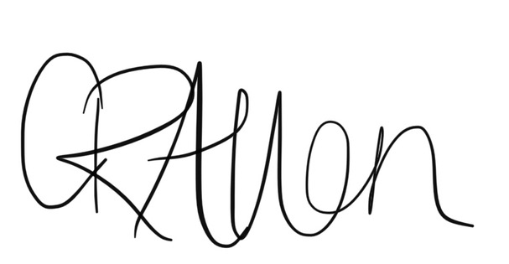
Next review date | September 2025

Julia Orridge
Head Teacher

Attendance Policy 2024-2025
At Buckminster Primary School we expect all pupils to attend school every day – the more pupils attend the more they can learn. Good attendance has a direct impact on achievement. We expect pupils to arrive on time and to strive for 100% attendance. Using the DfE Guidance for Maintained Schools, September 2022, we have developed our policy to ensure that communication about the expectations of parents, schools, governing bodies and the local authority is shared and understood. We aim to promote, among parents and children, a high level of awareness and the need for regular and prompt attendance. The school is required by law to record lateness and authorised absence separately from unauthorised absence and all of these areas will be monitored and supported to ensure the best attendance possible for all children.
Punctuality
All children from EYFS to Yr6 should be in their classroom by 8.55am. The gates will be locked at this time and all staff will be inside the building. Children should be in their classrooms promptly to enable registration and learning to start. When children arrive late to school, they can miss important information and introductions to lessons and may feel embarrassed to enter the classroom late. Parents have a legal responsibility to ensure their child is in school on time. Repeated lateness can also amount to a failure to attend school regularly and will be monitored by the school.
- Parents must notify school if they know their child is going to be late.
- Children who come into school via the office between 8.55am and 9.00am will be marked as late (before registers close).
- Registers are closed at 9.10am each morning and children who do not arrive in school in time for registration will be marked as late after registration.
- Lateness is monitored and if it becomes persistent then parents will be invited into school to discuss the issues and find strategies to resolve them.
- Persistent lateness can be reported to, and supported by, the Local Authority Attendance Team

Reporting absence
Parents are requested to notify the school, no later than 8.45am, that their child will be absent. This can be done via email to the school office, Dojo message to the class teacher / telephone call / message on the answerphone, or in person to the school office if dropping off a sibling.
Messages must not be given via WhatsApp (or other messaging services) to personal numbers belonging to members of staff as these cannot be guaranteed to be checked or passed on in a timely manner to enable appropriate safeguarding protocols in school to be followed. This also does not comply with our data protection procedures (GDPR).
A child’s absence will be recorded as authorised if they are ill. We expect parents to contact the school office in the morning on a daily basis for the duration of the illness to keep us informed and so we can offer support as appropriate.
A child’s absence will be recorded as unauthorised if the school considers the information received is not an acceptable reason for absence.
Absences will be monitored by the school. Where a pupil has frequent absences and the school is concerned, or attendance drops below 96%, the school may invite the parents into school for a meeting to discuss and offer support.
If there is a continued pattern of unauthorised absence or attendance does not improve, despite support from school, the Local Authority Attendance Team may become involved to offer further support.
Attendance figures will be reported as part of a child’s annual report in the summer term.
We welcome all pupils. Where pupils have long term medical conditions that impact on absences this information will be shared with the school so that appropriate support can be given. This may involve shared care plans and doctors’ recommendations as appropriate.
Where pupils are absent and we have received no message, we will ring all contact numbers given for the child and email parents. If we have not received any response, despite messaging in all ways available, we may then complete a home visit as part of our safeguarding procedures.

Medical Appointments and Evidence
We understand that on occasions, non-routine medical appointments, particularly hospital appointments, may have to be attended during school time. Where possible, appointments should be made at times that limit disruption to your child’s education.
Routine medical appointments, such as an eye test, dental or doctor appointments should be made outside of school hours when possible. We understand that this may not be possible in an emergency situation.
Most medical appointments take no longer than an hour or two, therefore we would expect children to only be absent for part of the day. For all medical appointments, parents are to provide a copy of the appointment card/ hospital letter for our records.
Acceptable medical evidence could be:
- Prescribed medication (must have label displaying pupil’s name and date)
- A copy of a prescription
- An appointment card showing the child’s name, date, surgery stamp
- Hospital appointment letters
- Doctor’s medical certificate or a Doctors letter.
Where pupils are required to take medication to support any illness or condition, but they are well enough to attend school, the school will be happy to support. Please see our administration of medication policy for further details or contact the school office and we will be happy to help.
Holidays During Term Time
The law states that holidays during term time can only be authorised by the Head Teacher under exceptional circumstances; proof of which will need to be obtained prior to authorisation. The school will consider each case individually but, where the amount of holiday time requested is in excess of 5 days over the course of the year, and the circumstances are not exceptional, then the Local Authority Attendance Team will be contacted for support and advice.
If your child has unauthorised leave of absence, you may be issued with a Penalty Notice of £160 per parent per child (discounted to £80 if paid within 21 days), or your case could be referred by the Local Authority directly to the Magistrates’ Court for the purposes of a criminal prosecution.
The school regards the regular attendance of children at school as being of utmost importance to each child’s education and development. It is for this reason that non-attendances are treated seriously. It remains the policy of the school to only authorise holiday during term time in exceptional circumstances. There are 190 days in a school year, leaving 175 non-school days for family holidays.
A holiday request form must be completed for all absence requests. The school is always happy to discuss this with parents to offer support and advice, please contact the school office for further information.

Responsibilities
The table below shows the summary of responsibilities for parents, schools governing bodies and the local authority in relation to attendance for all pupils. The full document can be found here: https://assets.publishing.service.gov.uk/government/uploads/system/uploads/attachment_data/file/1073619/Summary_table_of_responsibilities_for_school_attendance.pdf
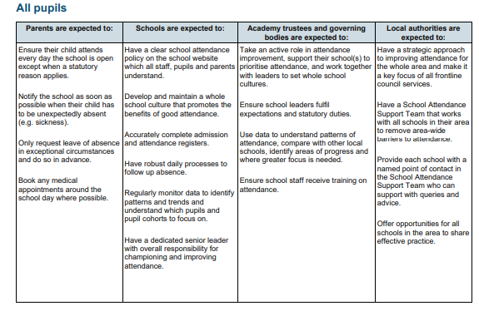
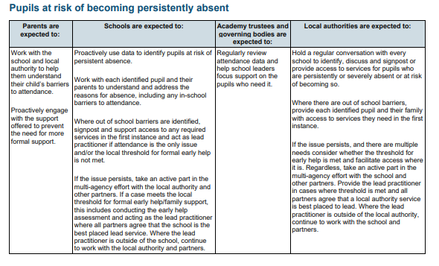
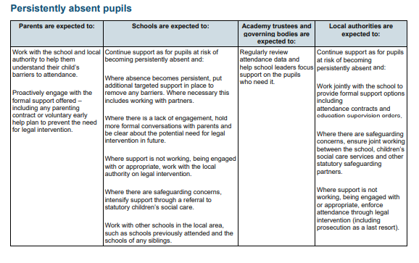
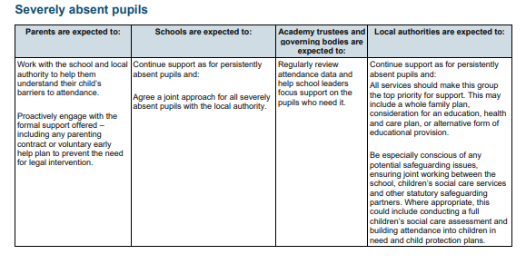
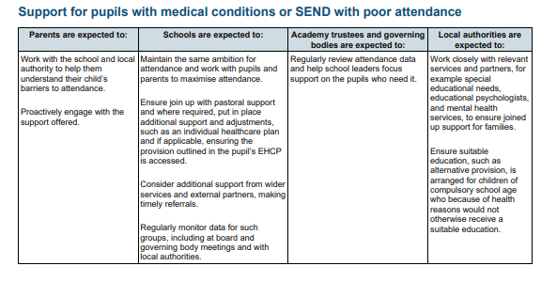

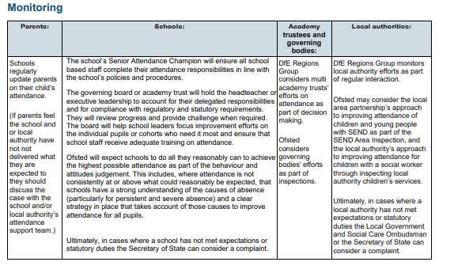

The designated senior leader for attendance is Mrs. Julia Orridge, Headteacher.
The school will work with the Local Authority and engage with their Targeted Support Meetings during the academic year 2024 – 2025 to support and monitor attendance in schools.
This policy will be reviewed by September 2025.

