

Charging and Remissions Policy 2024

Review date | September 2024
Signed: J Orridge (Head Teacher) | 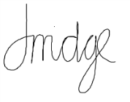
Signed: (CoG) | 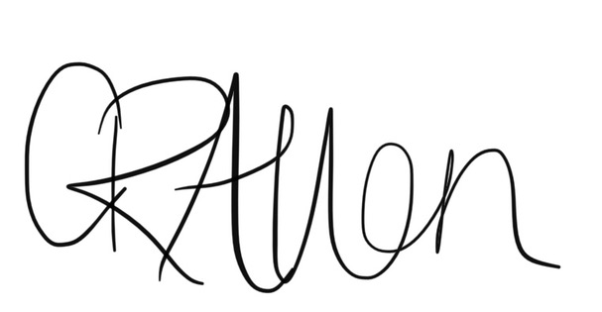
Next review date | September 2025

Julia Orridge
Head Teacher

Aims
Our school aims to:
- Have robust, clear processes in place for charging and remissions
- Clearly set out the types of activity that can be charged for and when charges will and will not be made
- Offer a range of activities and visits whilst minimising the financial barriers that may prevent some pupils from taking full advantage of these opportunities

Legislation and guidance
This policy is based on advice from the Department for Education (DfE) on charging for school activities and the Education Act 1996, sections 449 to 462 of which set out the law on charging for school activities in England.

Definitions
Charge: a fee payable for specifically defined activities
Remission: the cancellation of a charge which would normally be payable

Roles and responsibilities

The governing board
The governing board has overall responsibility for approving the charging and remissions policy, but can delegate this to a committee, an individual governor or the headteacher.
The governing board also has overall responsibility for monitoring the implementation of this policy.
Responsibility for approving the charging and remissions policy has been delegated to the Headteacher, Julia Orridge.
Monitoring the implementation of this policy has been delegated to the Headteacher, Julia Orridge

Headteachers
The headteacher is responsible for ensuring staff are familiar with the charging and remissions policy, and that it is being applied consistently

Staff
Staff are responsible for:
Implementing the charging and remissions policy consistently
Notifying the headteacher of any specific circumstances that they are unsure about or where they are not certain if the policy applies
The school will provide staff with appropriate training in relation to this policy and its implementation.

Parents/carers
Parents/carers are expected to notify staff or the headteacher of any concerns or queries regarding the charging and remissions policy.

Introduction
Any charges made for activities during school time are only intended to cover the cost of an activity or
service. They are not for profit.

Voluntary contributions
When organising school trips or visits which enrich the curriculum and educational experience of the children, the school invites parents to state their intention to pay/not pay before a contribution to the cost of the trip is asked for. All contributions are voluntary. If we do not receive sufficient voluntary contributions, we will not be able to book the trip. If a trip goes ahead, it may include children whose parents have not paid any contribution. We do not treat these children differently from any others and we do not put any additional costs onto those who do contribute.

If a parent wishes their child to take part in a school trip or educational event, but is unwilling or unable to make a voluntary contribution, we do allow the child to participate fully in the trip or activity providing it has educational benefit. Sometimes the school and/or PTFA pays additional costs in order to support the visit. Parents have a right to know how each trip is funded. The School provides this information.

If you have paid for a trip but then your child is absent from school there will be no refund. If the school or event cancels you will receive a full refund.

The following is a list of additional activities organised by the school, which require voluntary contributions from parents. These activities are known as ‘optional extras’. This list is not exhaustive:
- visits to museums;
- sporting activities which require transport expenses;
- outdoor adventure activities;
- visits to the theatre;
- school trips;
- musical events;
- educational visits related to the curriculum.

Residential visits
If the school organises a residential visit in school time or mainly school time, which is to provide education directly related to the National Curriculum, we do request a voluntary charge to cover the costs of travel expenses and board and lodging. It may also be stated that such an activity will not be able to take place unless enough contributions are received to finance the activity.

MET Minibus
The MET minibus is the most cost effective transport to and from local events for groups of 16 or less children. A small charge to cover the cost of staff, insurance and petrol is charged.

Music tuition
All children study music as part of the normal school curriculum. We do not charge for this.
There is a charge for individual or group music tuition if this is not part of the National Curriculum. The peripatetic music teachers teach individual or small group lessons. Charges are made for these lessons. Parents in receipt of Pupil Premium Funding are exempt from payment if there are sufficient funds – please contact the school if interested.

Swimming
The school organises swimming lessons for children in Year 2 – Year 6. These take place in school time and are part of the National Curriculum. We do charge for this activity, but it is subsidised by the school as much as possible. We inform parents when these lessons are to take place. This year, 2024-2025 swimming lessons for children in Yr2-Yr6 will take place every week in the Autumn term.

After School Activities
The school offers extra-curricular activities every day run by our qualified sports coach, teachers, learning support assistants or coaches from external organisations. A charge of £4 is made for all sessions, with a reduction for siblings and parents in receipt of Pupil Premium Funding. Children can only attend once payment has been received by school.

Breakfast Club and After School Club – Charged at £4 per hour.
The school runs a Breakfast Club and After School Club under ‘School Governance’. A charge is made for this to cover the cost of staffing and some equipment. Any Profit made is reinvested into resources for school. This charge is reviewed annually. Sessions required must be paid for in advance online, using vouchers, on line, by cash or cheque. Refunds will only be given if the school cancels the club. If your child is absent from school there will be no refund.
Children that attend the After school club, may wish to join an extra-curricular club for the first hour, and join the after-school provision after.

School Meals
The school provides hot meals for children at lunchtimes through Leicestershire County Council. The cost of a meal is set by LCC. Children in the Reception year, year 1 and 2 are entitled to a free hot meal. Key stage 2 children must pay for their meal. Dinners must be paid for prior to the lunch time either online, by cash or cheque and there will be no refund given if your child is absent from school.

Other charges
There may be a charge for miscellaneous services up to the cost of providing such services e.g. for providing a copy of an OFSTEDreport

